Earth Science Today
Russ Colson
Minnesota State University Moorhead
Astronomy and Planetary Science:
Observing planetary features and inferring processes
Topic: What can we learn about planetary processes by looking at surface features?
This discussion is a "science" discussion rather than a political or policy discussion. That is, your goal is to evaluate actual evidence and discuss what that evidence reveals about our universe.
Examine the surfaces and features of the Moon and Mars that are provided. Discuss and evaluate what these features reveal about processes on these planets (be sure to think about age of the surfaces and processes that have shaped those surfaces, including cratering, volcanism, tectonics, and weathering). You need to write a lab report for this activity. I will be less interested in your opinions than I am in the evidence you cite supporting those opinions and your reasoning justifying those opinions.
I have also included an atlas of the features of the Moon visible from Earth, in case you might someday want to examine the Moon with binoculars. The atlas includes maria (impact basins flooded with frozen lava), mountain ranges, impact craters, and lunar landing sites.
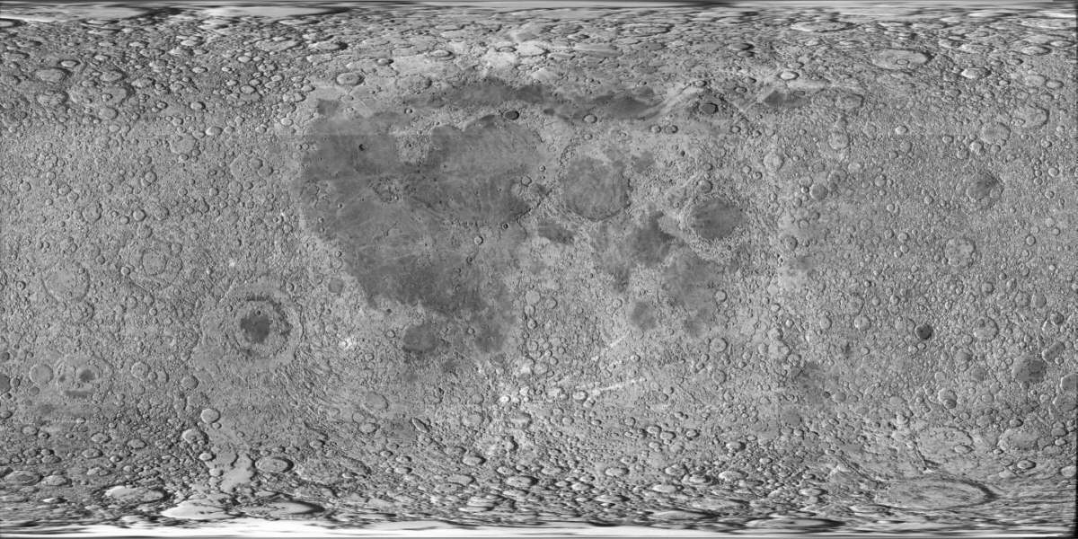
Projection of Moon surface (Map) based on images from the Clementine mission. (craters toward poles appear bigger due to the projection expanding the smaller polar areas to make a rectangle out of a spherical planet.)
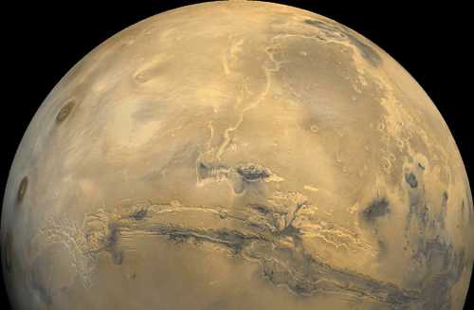
View of Mars
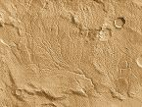
Mars from orbit
Viking 1 Lander view
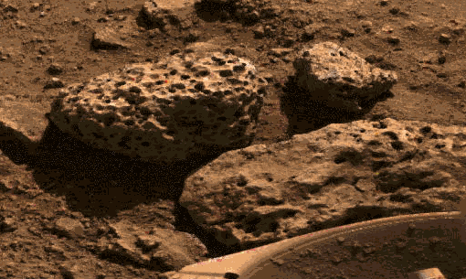
Mars lander view
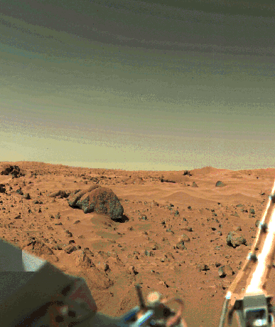.
Atlas of features visible with the naked eye or binoculars on the Near Side of the Moon
credit: www.arval.org.ve/MoonMapen.htm
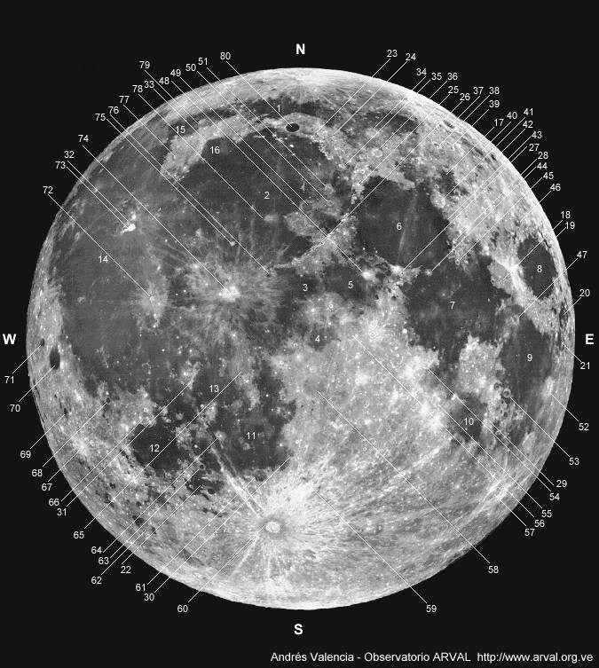
Maria:
North:
1- Mare Frigoris (Sea of Cold)
2- Mare Imbrium (Sea of Rains)
3- Sinus Aestuum (Bay of Seething)
Northeast:
4- Sinus Medii (Bay of the Center)
5- Mare Vaporum (Sea of Vapors)
6- Mare Serenitatis (Sea of Serenity)
7- Mare Tranquillitatis (Sea of Tranquillity)
8- Mare Crisium (Sea of Crises)
17- Lacus Somniorum (Lake of Sleep)
18- Palus Somnii (Marsh of Sleep)
19- Mare Anguis (Sea of Snakes)
20- Mare Undarum (Sea of Waves)
Southeast:
9- Mare Fecunditatis (Sea of Fecundity)
10- Mare Nectaris (Sea of Nectar)
21- Mare Spumans (Sea of Foam)
Southwest:
11- Mare Nubium (Sea of Clouds)
12- Mare Humorum (Sea of Moisture)
13- Mare Cognitum (Known Sea)
22- Palus Epidemiarum (Marsh of Diseases)
West:
14- Oceanus Procellarum (Ocean of Storms)
Northwest:
15- Sinus Roris (Bay of Dew)
16- Sinus Iridum (Bay of Rainbows)
Montes (Mountains):
Northeast:
23- Montes Alpes
24- Vallis Alpes (Alpine Valley)
25- Montes Caucasus
26- Montes Apenninus
27- Montes Haemus
28- Montes Taurus
Southeast:
29- Montes Pyrenaeus
Southwest:
30- Rupes Recta (Straight Wall)
31- Montes Riphaeus
Northwest:
32- Vallis Schröteri (Schröter's Valley) [Northwest of Crater Aristarchus, 73, and North of Crater Erodotus]
33- Montes Jura
Craters:
Northeast:
34- Crater Aristotle [on the East part of Mare Frigoris, 1]
35- Crater Cassini
36- Crater Eudoxus
37- Crater Endymion
38- Crater Hercules
39- Crater Atlas
40- Crater Mercurius
41- Crater Posidonius
42- Crater Zeno
43- Crater Le Monnier
44- Crater Plinius
45- Crater Vitruvius
46- Cráter Cleomedes
47- Crater Taruntius
48- Crater Manilius
49- Crater Archimedes
50- Crater Autolycus
51- Crater Aristillus
Southeast:
52- Crater Langrenus
53- Crater Goclenius
54- Crater Hypatia
55- Crater Theophilus
56- Crater Rhaeticus
57- Crater Stevinus
58- Crater Ptolemaeus
59- Crater Walter
Southwest:
60- Crater Tycho
61- Crater Pitatus
62- Crater Schickard
63- Crater Campanus
64- Crater Bulliadus
65- Crater Fra Mauro
66- Crater Gassendi
67- Crater Byrgius
68- Crater Billy [Mons Hansteen is to the North of Crater Billy]
69- Crater Crüger
70- Crater Grimaldi
71- Crater Riccioli
Northwest:
72- Crater Kepler
73- Crater Aristarchus [Crater Herodotus is West of Crater Aristarchus]
74- Crater Copernicus
75- Crater Pytheas
76- Crater Eratosthenes [near the Southwestern extreme of Montes Apenninus, 26]
77- Crater Mairan
78- Crater Timocharis
79- Crater Harpalus [Crater Pythagoras is North of Crater Harpalus]
80- Crater Plato
Manned Missions:
-- - Apollo 11 (July 20 '69) [Southwestern extreme of Mare Tranquilitatis, 7]
-- - Apollo 12 (November 19 '69) [Northern extreme of Mare Cognitum, 13]
-- - Apollo 13 (April 13 '70) [could not land North of Crater Fra Mauro, 65]
-- - Apollo 14 (February 5 '71) [North of Crater Fra Mauro, 65]
-- - Apollo 15 (July 31 '71) [Northern extreme of Montes Apenninus, 26]
-- - Apollo 16 (April 21 '72) [between Craters Theophilus and Hipparchus, 55 and 56]
-- - Apollo 17 (December 11 '72) [Southern extreme of Montes Taurus, 28]
Notes:
The directions East (E) and West (W) marked on the graphic, are directions as seen from the Moon; These are opposite of East and West as seen from the Earth

