Parallax class activity.

How far away are the stars?

Fun with Math!

person 1: Measure out some distance X, and stand at point 1. This is like the distance to a star, which in real life we can’t measure with a tape measure!. (If there is time, we will do two distances, one quite short, say 10 feet, and one longer, say 50 feet, so that you can see the effect of distance on your ability to measure accurately).

person 2: measure distance Y. This is like the distance between the position of Earth in July and its position in January, which in real life is measured by measuring the distance to the Sun.

person 3: measure the angle a, from point 2 to point 1. Remember, the angle must be relative to the line between points 2 and 3. This is like measuring the angle of the apparent shift in a star’s position against the background stars (parallax).

person 4: measure the angle a, from point 3 to point 1. Remember, the angle must be relative to the line between points 2 and 3. This is like measuring the angle of the apparent shift in a star’s position against the background stars (parallax).

Like all of my activities, you can’t simply follow the recipe! You have to think about what you are doing and understand it in order to do it right!

calculation: add the two angles together and divide by two to get an average. Distance X can be determined from the trigonometric relationship

Tan (a) = X/(Y/2) or Tan (b) = X/(Y/2)

so that X = Y/2 •Tan (a).

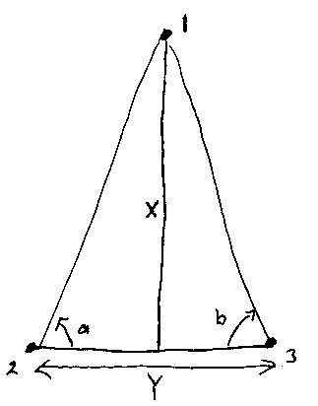
Make sure that your calculator is calculating Tan in degrees rather than radians (if you measure the angle in degrees).

2nd version
Distance of Stars Game:

Get into teams of 3-4 people. There needs to be an even number of teams.

Each team will pair with another team.

Team 1: your job is to create a triangle such as shown below, using tape to define the bottom line ("Y"), and putting one of your team members at position 1. Person 1 must be positioned on an imaginary line drawn from the center of the tape line, and perpendicular to the tape line. You will measure accurately the distance from the exact center of the tape line to the person standing at point 1 (distance X). You will not reveal this distance to team 2.

Team 2: Start planning your strategy while team 1 works. Once team 1 has set up the triangle, your job is to measure the distance from the center of the tape line to position 1, without actually going to position 1. Position 1 is like a distant star, you can't go there. So, you have to determine the distance by measuring an appropriate angle and any distances along the tape line that you need. There are tape measures, rulers, and protractors available.

After using triangulation to determine the distance to point 1, compare your value to the "real" value measured by team 1. Determine the percentage error in your measurement. (% error equals the absolute value of the difference between the measured and real values, divided by the real value, times 100%)

Switch team roles. Team 2 do task of Team 1 and Team 1 do task of Team 2.

The winning team is the team with the smallest percentage error.
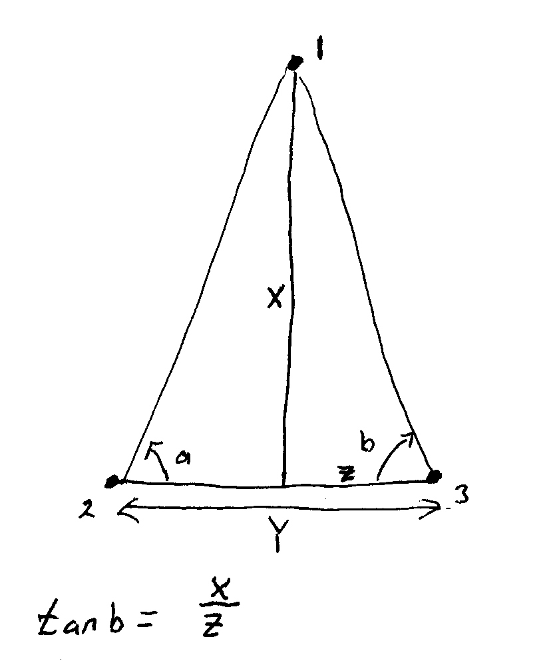
To turn in:

A sheet of paper including the following:

- Your calculated distance (remember, you can't measure the distance to the star directly!!!!)

- The actual measured distance (from Team 1)

- Your percentage error.

