Earth Science Today Lab: Finding earthquakes.

Part I. Finding the distance to earthquakes given difference in arrival times

From 8th Grade science book: Understanding seismic wave travel times (12 points)
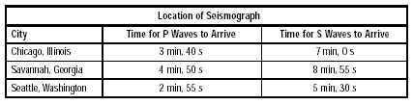
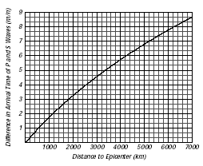
Interpreting Graphs: What is
each city’s distance from the
epicenter?
Chicago:
Savannah:
Seattle:

Part II: Finding the location of an earthquake and when it occurred using arrival times for P and S waves at three seismograph stations.
Hints:
Step 1: You need to figure out how far each station is from the earthquake. The graph shows travel time, not arrival time or difference in travel times for P and S waves. Therefore, you have to figure out how to use the graph with the information that you have (which is arrival time). Remember, it is the DIFFERENCE IN TRAVEL TIMES between the P and S waves that allows you to figure out distance to an earthquake.

Step 2: You need to plot circles, and find where they intersect to determine where the earthquake occurred.

Step 3. You need to figure out WHEN the earthquake happened. In step 1 above, you figured out the distance to the earthquake based on the measured arrival times for P and S waves. Using the graph and the known distance, you can determine the TRAVEL TIMES for the waves (which obviously are not the same as the arrival times). If you know the travel time and the arrival time, you can figure out when the earthquake happened.

If you still have trouble figuring out step 3, think of an analogy. Suppose that my arrival time at class is 1pm. My travel time is 5 minutes. When did I have to leave my office to arrive at 1pm:?

