Earth Science Today
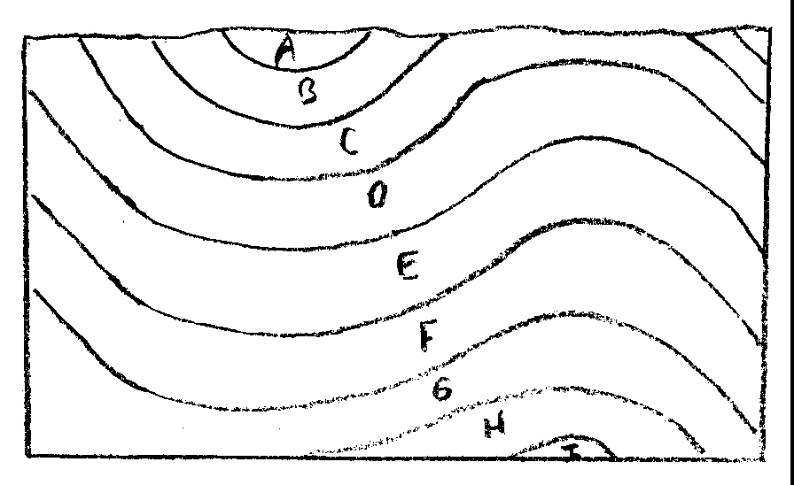
Mapping and Oil deposit lab
X
Y
Z

Considering the Cross-sectional view above, you will predict where oil will accumulate (which layer and which location in the cross-section), and where to drill (remember, you have to drill from the SURFACE!)
The following layers are IMPERMEABLE: A, B, C, E
The following layers are PERMEABLE: D, F, G, H, I
The following layers originally contained a lot of accumulated plankton etc: D, G

1) Show IN THE CROSS-SECTION where oil will accumulate. There are TWO places where it will accumulate, show both.

2) Where at the surface would you drill to reach the oil? (X, Y, or Z)
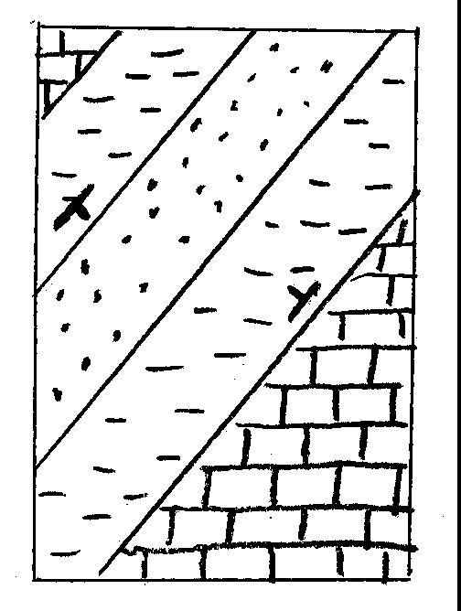
A
A'
Considering the map at left, and recognizing the symbols for sandstone (dots), shale (dashes), and limestone (blocky), do the following:

3) Draw a line down the middle of the fold (this is called the axis of the fold).

4) Is the fold an anticline or a syncline?

5) Draw a cross-sectional view from point A to point A'

A
A'

6) Do the rocks in the map above indicate a
Marine Transgression or a Marine Regression?
Consider the map below that shows both a syncline and an anticline.
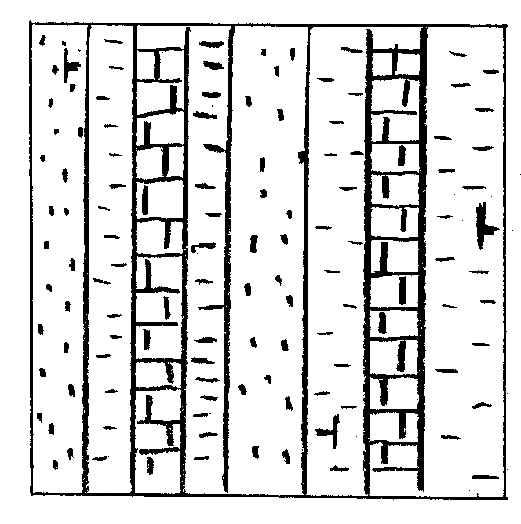
B'
B
6) Draw a syncline symbol along the axis of the syncline (symbol is a line with arrows:

7) Draw an anticline symbol along the axis of the anticline (symbol is a line with arrows:

8) Where would you drill for oil (indicate on the map with an arrow and "drill here" label)?

9) Draw a cross-sectional view from B to B':

B
B'

10) Which of the following best describes the events recorded by these rocks?
a) Transgression
b) Regression
c) Regression then Transgression
d) Transgression then Regression

