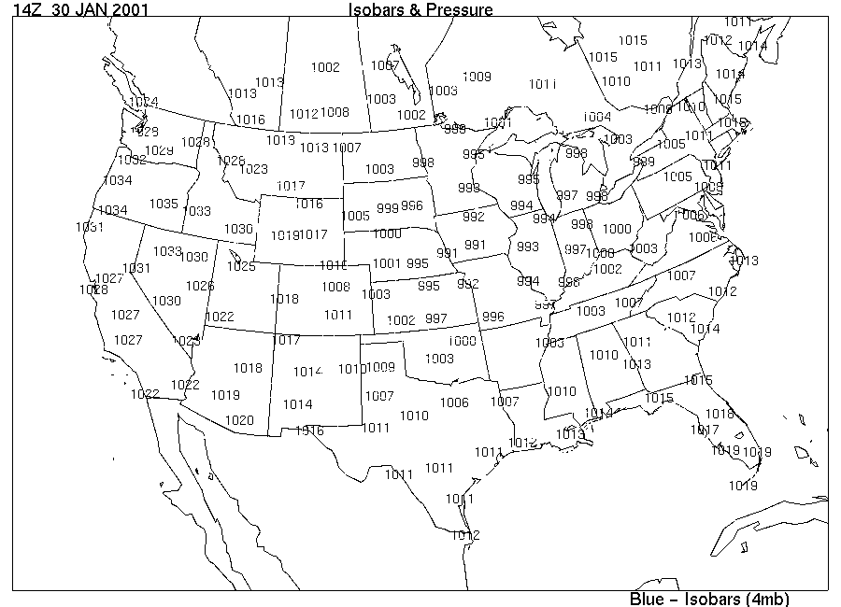
Draw isobars on the map below, 992, 996, 1000, 1004, 1008, etc. Values in millibars. You will need to interpolate between measured pressure values. On the resulting map, draw arrows to show expected wind directions in the following locations: Fargo, NC Kansas, N. Arkansas, Great Salt Lake, Central CO, NW PA, N CA.
